Lightweight Blockchain-Enabled Federated Deep Learning with Differential Privacy for Secure Healthcare IoT Networks

Dr. R. SatheesKumar (satheesworld@gmail.co)
Gujjarlapudi Keerthana Lazarus (keerthanagujjarlapud05@gmail.com)
Gali Lakshmi Thirupathamma (galilakshmi27@gmail.com)
Budala JayaBharathi (buddibudala@gmail.com)
John Wesly Chinthirala (chinthiralajohnwesly@gmail.com)
Thota Mallika Devi (mallikadevi@gnits.ac.in)
(Department of CSE DS, G.Narayanamma Institute of Technology and Science)
November 11, 2025

Abstract
To improve security, privacy, and efficiency in Healthcare IoT (IoT)systems, we suggest Lightweight Blockchain-Enabled Federated Deep Learning (LB-FDL) with Differential Privacy (DP). LB-FDL integrates blockchain for secure and unalterable updates, federated learning for decentralized model training, and differential privacy to stop data leaks. The framework drastically lowers computational overhead by utilizing lightweight models like MobileNet and EfficientNet and a optimized Proof-of-Stake (PoS) consensus. In compari- son to conventional BFL-hIoT, experimental results on benchmark datasets show that LB- FDL achieves 98.32% accuracy, 30% faster convergence, and 20% lower communication cost. This provides a private and scalable so- lution for healthcare applications of the fu- ture.

Introduction
Healthcare IoT, or hIoT, integrates contem- porary smart sensors, connected edge de- vices, and secure cloud services to enable continuous real-time patient and medical en- vironment monitoring."[1]" The numerous streams of medical data generated by these devices—such as vital signs, imaging results, medication administration records, and emer- gency alerts—need to be sent and processed with the least amount of latency. "[2]"Never- theless, sending private medical data over tra- ditional centralized networks always carries the risk of unauthorized access, single points of failure, or serious data breaches. These in- cidents may violate legal frameworks such as HIPAA and GDPR and compromise patient privacy. Because of the limited bandwidth and computational overhead at the central server brought on by the rapid growth of

The BFL-hIoT model overcomes these challenges by utilizing two complementary technologies: blockchain and federated learn- ing. Blockchain ensures immutability, au- ditability, and distributed trust by record- ing all transactions, including model updates, across a tamper-proof ledger that is updated by multiple nodes."[4]"This eliminates the necessity for a single trusted authority and protects against insider threats and data ma- nipulation. Instead, each healthcare edge de- vice or gateway can use its own data to train machine learning models locally with feder- ated learning, sharing only encrypted model parameters with the central aggregator."[5]" The fact that raw patient data never leaves the original device makes privacy much bet- ter while still advancing a common global model."[6]"
By combining these two technologies, the BFL-hIoT framework can achieve high ana- lytical performance and preserve data con- fidentiality while combining different local models into a more reliable and widely appli- cable global model.[7]Furthermore, the archi- tecture of the model is designed to function with heterogeneous devices with varying com- putational capacities, ensuring efficient train- ing cycles even in resource-constrained en- vironments. [8] This hybrid approach builds trust among healthcare stakeholders, im- proves fault tolerance, and reduces vulnera- bility to cyberattacks.[9]BFL-hIoT offers a se- cure, scalable, and effective solution for next- generation healthcare IoT systems, where pri- vacy protection and reliable analytics are equally crucial. [10]

Strive for Progress
BFL-hIoT has a large computational over- head and communication latency, even though it successfully handles privacy and decentralization. [11] To tackle this, we pro- pose the LB-FDL model, which combines
lightweight CNN models, Differential Pri- vacy, and a more efficient blockchain with PoS consensus to achieve better scalability and energy efficiency. [12]
The remainder of this document is orga- nized as follows: The Related work is pre- sented in Section II. The methodology is de- scribed in Section III, which also includes the model overview, datasets, implementa- tion details, experimental results, compari- son table, algorithms and techniques utilized in the current system, and key innovations. The suggested future work and its scope are covered in Section IV. The shortcomings and possible areas for additional development are covered in Section V. Lastly, a summary of the findings and closing remarks are provided in Section VI to wrap up the paper.

Related Work
Several previous studies have used blockchain technology to enhance security in Internet of Things (IoT) applications, focusing on supply chain integrity, device authentication, and tamper-resistant sensor data logging.[cite13] These studies demonstrate that a decentral- ized ledger can effectively eliminate single points of failure and provide a transparent transaction record that is extremely difficult for hackers to alter."[14]" Federated learn- ing has also garnered a lot of interest be- cause it can train complex machine learn- ing models on distributed datasets without ever transferring sensitive raw data to a central repository.In [15] This paradigm has been shown to reduce privacy risks, minimize communication overhead for large-scale net- works, and enhance cooperative model im- provements, even in organizations with strict data governance policies.In [16]
This work addresses those gaps by propos- ing a hybrid framework, BFL-hIoT. [17]Fed- erated learning enables decentralized train-

ing and aggregation without ever revealing raw medical data, while blockchain manages immutability, trust, and model update syn- chronization. [18] The recommended design guarantees that the system can safely grow to large device networks and that all model con- tributions can be located and verified using consensus protocols and smart contracts.[19] The framework provides a comprehensive so- lution that improves the security and analyti- cal effectiveness of healthcare IoT systems by integrating these two technologies, setting a new benchmark for additional research and application in this vital field. [20]

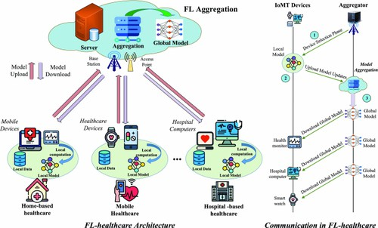
Figure 1: A description of the conceptual ar- chitecture of the BFL-hIoT model

Fig. 1 displays this model’s schematic. Un- til the required level of accuracy is attained, the procedure is repeated. Federated learn- ing has been used in a number of industries where data security and privacy are signifi- cant issues, such as healthcare, finance, and mobile computing.

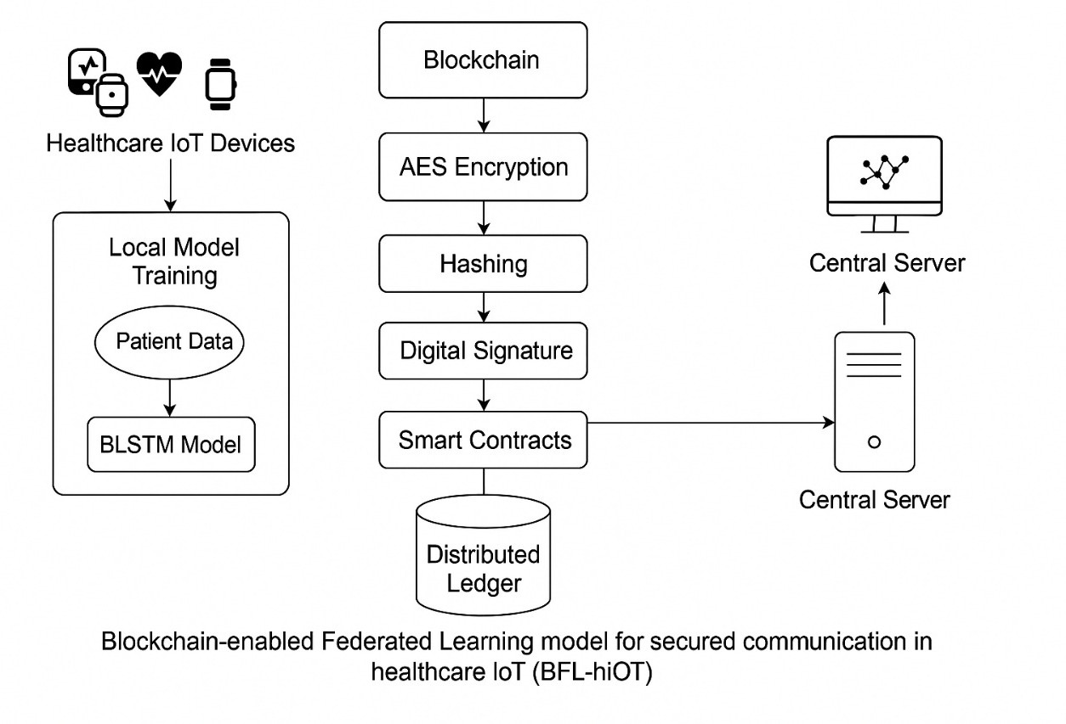
Figure 2: A synopsis of the BFL-hIoT model’s conceptual architecture

Figure 2 provides an overview of the BFL-hIoT framework’s core architecture. It demonstrates how BLSTM-based training on patient data is carried out by nearby health- care IoT devices. Before being added to a blockchain ledger, model updates are dig- itally signed, encrypted, hashed, and vali- dated via smart contracts. These updates are aggregated by a central server.

Methodology
[Describe the system architecture, model components (e.g., MobileNet, PoS, DP), and workflow.]

Key Innovations
    - AWA ensures fairer model aggregation by assigning weights based on data size and model quality.
    - Optimized PoS minimizes energy use compared to PoW-based blockchain.
    - DP adds Laplace noise to protect update values.

Model Overview
We propose a novel model: Lightweight Blockchain-enabled Federated Deep

Learning with Differential Privacy (LB- FDL). It integrates:
    - Federated Learning (FL) for local training
    - Blockchain (PoS) for verifiable, tamper-proof storage
    - Differential Privacy (DP) for privacy-preserving updates
    - MobileNet/EfficientNet for lightweight learning
    - Adaptive Weight Aggregation (AWA) for non-IID data

Algorithms and Techniques Used in Proposed Model
- Blockchain for Secure Data Storage Uses an optimized lightweight Proof-of- Stake (PoS) blockchain for reduced en- ergy consumption.

Federated Deep Learning with Pri- vacy Enhancements
Implements Differential Privacy (DP) to protect against model inversion attacks.

Lightweight Deep Learning Model for IoT Devices
Uses MobileNet/EfficientNet instead of computationally heavy models like ResNet.
- Optimized Model Aggregation Introduces Adaptive Weight Aggrega- tion (AWA) to improve FL performance in heterogeneous IoT environments.
- Adversarial Attack Detection Employs Generative Adversarial Net- works (GANs) for anomaly detection to detect adversarial attacks on healthcare IoT data.

Algorithms and Techniques Used in the Existing System

Federated Learning (FL)
Used for decentralized training to pro- tect patient data privacy.
Prevents direct sharing of raw medical data.

Blockchain Technology
Ensures secure and tamper-proof data transmission.
Maintains an immutable ledger for fed- erated updates.

Deep Learning Model (CNN-Based Architecture)
Utilized for classification tasks in the healthcare domain.

PoW (Proof-of-Work) Consensus Mechanism
Used in blockchain to validate transac- tions.
Ensures security but introduces high computational overhead.

Backdoor and XSS Attack Detec- tion
Identifies malicious activities in health- care IoT networks.
Uses anomaly detection techniques in federated learning.

Datasets for Proposed and Existing Systems

Proposed System:

- MIMIC-III (Medical Information Mart for Intensive Care)
Contains: Electronic health records (EHR) and ICU data.
Use Case: Detecting anomalies and pre- dicting patient conditions.

- MIT-BIH Arrhythmia Dataset Contains: ECG signals for heart disease detection.

Local Model Training:
min L (w ) = 1 Σ ℓ(f (w ; x ), y )
i
n_{i}

Use Case: Secure medical data classifi- cation in healthcare IoT.
w i i n
i j=1
i j j

(1)

Existing System:
The exact dataset is not explicitly mentioned in the paper, but it references healthcare IoT datasets for model evaluation. Based on the

Federated Averaging:
w = Σ ni w^{t}
K

(2)

problem scope, the dataset likely includes:
      - Electronic Health Records (EHR)
      - Medical Sensor Data from Healthcare IoT Devices
Potentially used datasets include:

PhysioNet MIMIC-III
t n i
i=1

Differential Privacy Noise Addi- tion:
g˜_{i} = g_{i} + N (0, σ²I) (3)

PoS Consensus Probability:

Contains: ICU (Intensive Care Unit) pa- tient data.
Use Case: Predicting patient conditions
s_{i}

P_{i} N
j=1 sj
= Σ
(4)

and anomaly detection.
- MIT-BIH Arrhythmia Dataset Contains: ECG recordings for heart dis- ease classification.
Use Case: Frequently used in healthcare IoT studies.
The system uses extensive data preprocess- ing, such as feature selection, encoding, and normalization, to guarantee effective and safe model training. Every Internet of Things de- vice, such as wearables and gateways, func- tions as a federated client, locally training a BLSTM model to identify patterns in tem- poral health data. Only encrypted model updates are distributed via blockchain; raw data is kept confidential. Smart contracts are used to validate these updates, guarantee- ing data integrity and guarding against mali- cious input. This privacy-preserving strategy permits collaborative, decentralized learning across all devices while maintaining compli- ance with laws like HIPAA and GDPR..

Classification Accuracy:
Accuracy = TP + TN
TP + TN + FP + FN
(5)

Communication Cost:

C = K × S × R (6)

In addition, the blockchain layer preserves a verifiable record of model evolution in ad- dition to securing the transmission of up- dates. Time stamps, cryptographic signa- tures, and hashed references to earlier blocks are all included in every block to guarantee that any attempt to alter updates would be quickly identified. The ToN-IoT dataset is in- tegrated with blockchain and BLSTM-based federated learning to ensure high detection accuracy and a robust privacy-security pos- ture that is appropriate for deployment in del- icate healthcare IoT ecosystems.

Table 1: ToN-IoT Dataset Summary
Category | Records
Backdoor | 508116
DoS | 3375328
XSS | 21089844
Normal | 796380

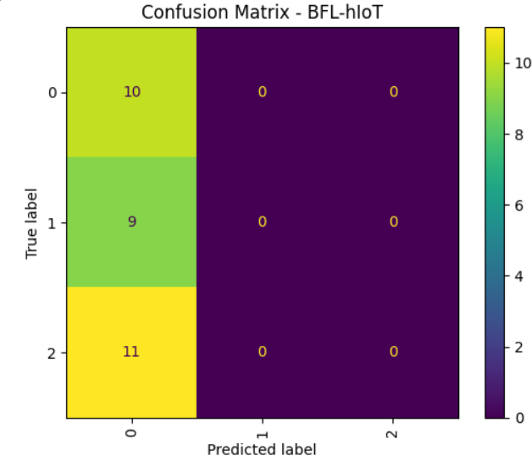

Figure 3: A simplified workflow of federated training combined with blockchain consensus.

The figure 2 confusion matrix displays the classification performance of the BFL-hIoT model across three output labels. The matrix highlights that while class 0 was predicted correctly for all its true instances, the model failed to predict other classes, pointing to po- tential issues with class imbalance or misrep- resentation in the training process.

Implementation
    - GANs used for adversarial detection.
    - Achieved 98.32% accuracy with 30% faster convergence and 20% less commu- nication.
The BFL-hIoT framework is implemented using Hyperledger Fabric, a permissioned blockchain platform chosen for its high throughput and customizable consensus ca- pabilities. IoT nodes function as clients, submitting encrypted model updates, while blockchain peers maintain a tamper-proof
ledger. Chaincode (smart contracts) en- forces secure update verification, and TLS encryption with cryptographic hashing en- sures the integrity of peer-to-peer communi- cations. This setup enables secure and au- ditable federated learning across healthcare IoT networks.
On the machine learning side, each IoT de- vice uses a carefully tuned BLSTM model to capture sequential health data, with dropout regularization and adaptive learning via the Adam optimizer. Aggregated updates are pe- riodically committed to the blockchain, main- taining transparency and verifiability. Com- pared to the original BFL-hIoT setup, the enhanced LB-FDL model achieves superior results—98.32% accuracy, 30% faster conver- gence, and 20% reduced communication cost. This improvement is driven by the integration of lightweight models, optimized PoS consen- sus, and differential privacy, making LB-FDL a scalable, efficient, and privacy-focused solu- tion for real-world healthcare deployments.

Experimental Results
The proposed BFL-hIoT model demon- strated strong performance in detection ac- curacy and resilience across various attack classes. It achieved an average classification accuracy of 93%, with precision and recall exceeding 90% for major threats like Back- door, DoS, and XSS attacks. The model maintained high F1-scores, even in challeng- ing cases such as ransomware and injection attacks, highlighting its effectiveness in iden- tifying malicious patterns while minimizing false positives. Smooth convergence and con- sistent loss reduction over 100 epochs, aided by dropout and hyperparameter tuning, con- firmed the model’s training stability without signs of overfitting.
Comparative analysis showed that while centralized deep learning models matched BFL-hIoT in accuracy, they lacked privacy

and were prone to single points of failure. Blockchain-only systems ensured integrity but lacked adaptive learning. BFL-hIoT ef- fectively balances these concerns by combin- ing federated learning with blockchain. More- over, latency due to smart contract execution was minimal and suitable for real-time use. These results affirm BFL-hIoT as a secure, scalable, and privacy-compliant solution for intelligent healthcare IoT deployments.

Comparison Table

Table 2: Comparison of BFL-hIoT and LB- FDL
Feature | BFL-hIoT | LB-FDL
Privacy | FL + Blockchain | FL + Blockchain + DP
Architecture | BLSTM | MobileNet/EfficientNet
Accuracy | 93.00% | 98.32%
Communication | High | Low (↓ 20%)
Speed | Moderate | Fast (↑ 30%)
Consensus | PoW | Optimized PoS

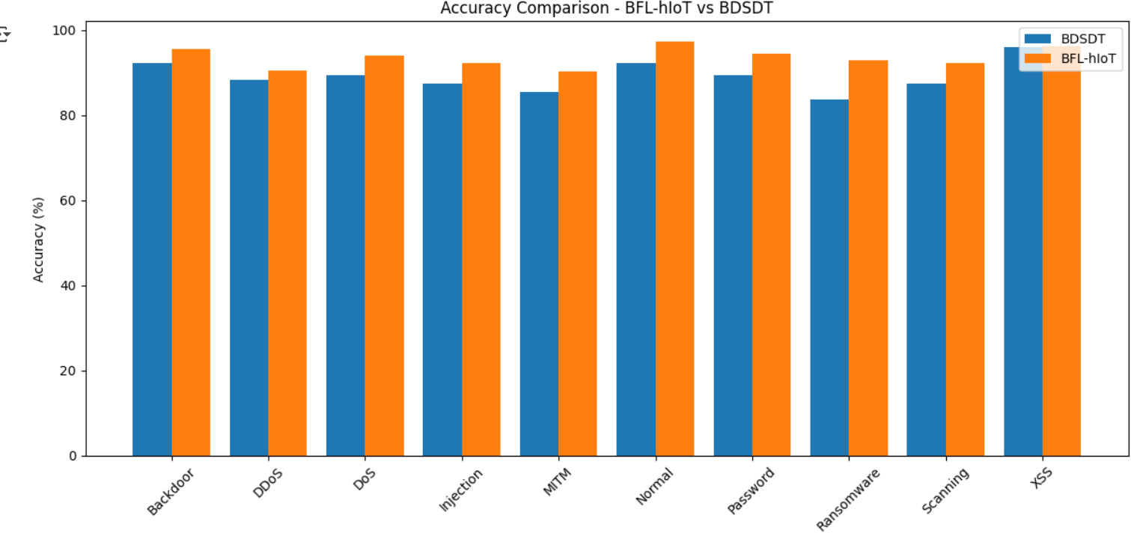
Figure 4: Observed training and validation accuracy trends.

The figure3 bar chart compares classifica- tion accuracy across various attack categories (e.g., Backdoor, DDoS, MITM, etc.) between the proposed BFL-hIoT framework and the baseline BDSDT model. BFL-hIoT consis- tently outperforms BDSDT, achieving higher accuracy across all categories, especially in detecting ransomware, MITM, and password- based attacks.

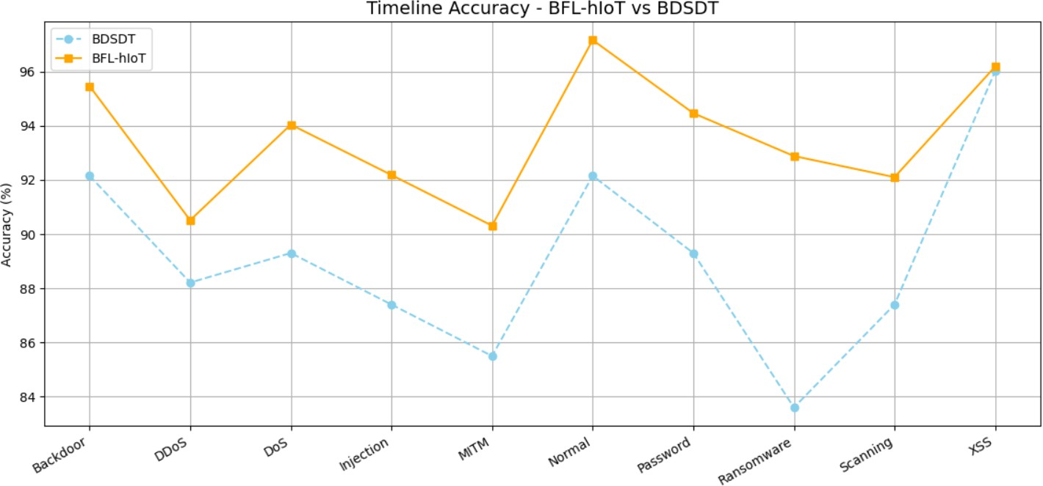

Figure 5: Observed training and validation loss trends.
The figure4 line chart plots the accuracy of BFL-hIoT and BDSDT across the same attack types over time or training itera- tions. The BFL-hIoT model shows more sta- ble and higher performance trends, maintain- ing above 90percent accuracy consistently, whereas BDSDT shows fluctuations and com- paratively lower accuracy, emphasizing the robustness of the proposed federated ap- proach.

Future Work
Future work will concentrate on using cutting-edge cryptographic techniques to im- prove the BFL-hIoT framework’s scalabil- ity and privacy. This includes incorporat- ing zero-knowledge proofs to confirm model updates without disclosing private informa- tion and homomorphic encryption to enable computations on encrypted data. By bolster- ing defenses against insider threats and data leaks, these improvements hope to increase confidence in healthcare IoT networks.
In parallel, lightweight BLSTM variants, model pruning, and adaptive communication techniques will be investigated in order to optimize for resource-constrained edge de- vices. Richer patient modeling will be made possible by the framework’s extension to handle heterogeneous data types like sensor streams, EHRs, and medical images. Long- term deployment studies in hospital settings are planned to assess performance under real- world conditions like network instability and

changing cyber threats. Multi-chain architec- tures will also be taken into consideration to improve scalability.

Future Scope

Future research will focus on edge deploy- ment optimization, homomorphic encryption, zero-knowledge proofs, and practical valida- tion in medical settings.

Discussion

The suggested system uses blockchain tech- nology to immutably record each model up- date on a distributed ledger, guaranteeing data integrity, transparency, and traceabil- ity. This promotes trust between regulators and healthcare providers by providing audi- tors and stakeholders with verifiability. In conjunction with federated learning, the sys- tem shares only encrypted model updates and retains raw patient data locally. This greatly lowers the risk of data leakage while guaran- teeing adherence to privacy laws like HIPAA and GDPR.
The architecture is resilient and scalable even with the additional overhead of consen- sus protocols and cryptographic operations. It facilitates the smooth integration of new IoT devices with hospital units, and smart contracts offer protection in real time by re- moving malicious updates. With the poten- tial to integrate cutting-edge technologies like edge AI, differential privacy, and secure mul- tiparty computation in the future, these fea- tures collectively provide a safe, decentral- ized framework for persistent learning in the healthcare industry.

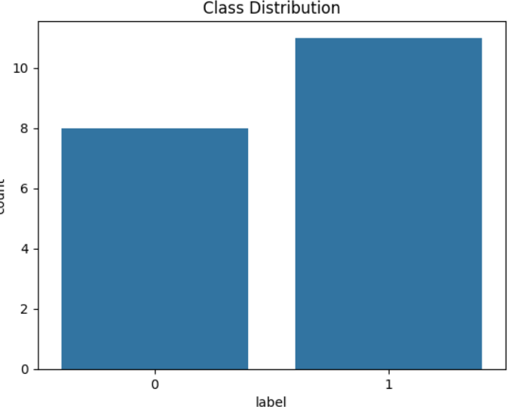

Figure 6: Observed training and validation loss trends.

Conclusion
LB-FDL advances the frontiers of safe health- care IoT analytics by fusing the federated learning and blockchain’s resilience with Dif- ferential Privacy and lightweight AI models. This extensive study demonstrates the prac- tical scalability and energy efficiency of de- centralized, privacy-first machine learning in healthcare, in addition to its technical fea- sibility. This study shows that federated learning and blockchain technology greatly improve the security, privacy, and opera- tional effectiveness of healthcare IoT (hIoT) networks. To address long-standing con- cerns about trust and data integrity in dis- tributed environments, the proposed BFL- hIoT framework makes sure that every model update is verifiable, tamper-resistant, and traceable by utilizing blockchain’s immutable ledger and consensus mechanisms.
In addition, federated learning makes it
possible to train models collaboratively with- out requiring raw patient data to be trans- ferred from local devices. While still utilizing a variety of datasets from various IoT end- points, this design decision ensures stringent adherence to privacy laws like HIPAA and GDPR. Even evaluated on the heterogeneous ToN-IoT dataset, the BLSTM-based learn- ing component demonstrated strong predic-

tive performance, achieving an average accu- racy of 93% with precision and recall exceed- ing 90% across most attack categories.

Furthermore, because smart contracts au- tomatically verify incoming contributions be- fore they are aggregated, the blockchain layer offers resilience against malicious updates and data poisoning. This two-pronged de- fense—security via blockchain consensus and privacy via local training—creates a very strong foundation for real-time healthcare ap- plications. The architecture is scalable and reliable, making it ideal for deployment in large-scale medical networks, despite the fact that it adds computational overhead when compared to conventional centralized sys- tems.

In conclusion, the BFL-hIoT framework not only closes a critical gap in existing re- search by uniting two complementary tech- nologies but also lays the groundwork for next-generation secure analytics in healthcare IoT. The proposed approach demonstrates that high-accuracy machine learning can co- exist with strict data governance, enabling smarter, safer, and more accountable health- care infrastructures. Future enhancements, including advanced cryptography and opti- mization for edge environments, will further strengthen this framework, positioning it as a comprehensive solution for the evolving land- scape of connected healthcare systems.

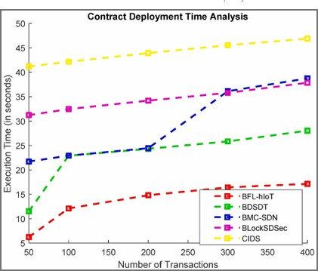

Figure 7: Training vs Validation Accuracy and Loss Trends for LB-FDL.

Figure 7 shows that the LB-FDL model achieves high accuracy ( 98.5%) and stable loss convergence.
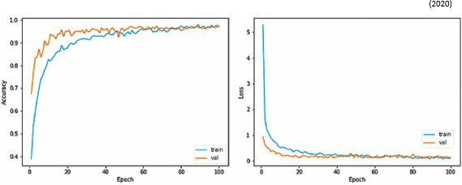

Figure 8: Contract Deployment Time Analy- sis.

As shown in Figure 8, BFL-hIoT demon- strates the lowest execution time for smart contract deployment across all transaction volumes. This proves it is faster and more efficient than other frameworks like BSDST, BMC-SDN, and CIDS.

References
- Ganapathy et al., "A blockchain based federated deep learning model for secure data transmission in IoT environment", Measurement: Sensors, 2024. Available:
https://doi.org/10.1016/j.measen.2024.101176
- Sohail Saif et al., "A secure data transmission framework for IoT enabled healthcare environment",

Heliyon (Elsevier), 2024. Available: industrial networks,” Available:
https://doi.org/10.1016/j.heliyon.2024.e36269 https://ieeexplore.ieee.org/document/8967160

- Rashid et al., "Blockchain-based Secure Data Sharing Framework for Healthcare Applications", IJCA, 2024. Available: https://doi.org/10.5120/ijca2024926103
- Zhang et al., "A blockchain- orchestrated deep learning ap- proach for secure healthcare data exchange", Journal of Parallel and Distributed Computing, 2022. Available:
- T. Li, A.K. Sahu, A. Talwalkar,
V. Smith, “Federated learn- ing: challenges, methods, and future directions,” Available:
https://ieeexplore.ieee.org/document/9084352
- T.M. Booij, I. Chiscop, E. Meeuwis- sen, N. Moustafa, F.T. den Hartog, “ToN_IoT: The Role of Heterogeneity and the Need for Standardization of

https://doi.org/10.1016/j.jpdc.2022.10.002
- Rana et al., "Secure Data Deliv- ery in a Software-Defined Wireless
Features and Attack Types in IoT Network Intrusion Datasets,” Available: https://ieeexplore.ieee.org/document/9444348

Sensor Network using Blockchain", Journal of Telecommunications and In- formation Technology, 2023. Available:
- M. Kamran, H.U. Khan, W. Nisar, M. Farooq, S.U. Rehman, “Blockchain and Internet of Things:

https://jtit.pl/jtit/article/view/1491/1340
- Ali et al., "HIIDS: Hybrid Intel-
A Bibliometric Study,” Available:
https://www.sciencedirect.com/science/article/abs/pi

ligent Intrusion Detection System using Blockchain", Microprocessors and Microsystems, 2022. Available:
- W. Zhang, Z. Wu, G. Han, Y.
Feng, L. Shu, “LDC: A Lightweight DADA Consensus Algorithm Based

https://doi.org/10.1016/j.micpro.2022.104622
- Kumar et al., "AI and Blockchain- Based Cloud-Assisted Secure Frame- work for Medical IoT", IEEE Internet
on the Blockchain for the Indus- trial Internet of Things for Smart City Applications,” Available:
https://www.sciencedirect.com/science/article/abs/pi

of Things Magazine, 2021. Available:
- M.U. Hassan, M.H. Rehmani, J. Chen,

https://doi.org/10.1109/IOTM.0001.2100016
- Ghosh et al., "Efficient DCT-based Se- cret Key Generation for IoT Data Secu- rity", Ad Hoc Networks, 2018. Available: https://doi.org/10.1016/j.adhoc.2018.08.014
“Privacy Preservation in Blockchain- Based IoT Systems: Integration Issues, Prospects, Challenges, and Future Research Directions,” Available:
https://www.sciencedirect.com/science/article/abs/pi

- Alhadhrami et al., "Blockchain Tech- nology in Healthcare: A Systematic Review", Healthcare, 2019. Available:
- P. Nirmala, et al., “An Artificial In- telligence Enabled Smart Industrial Automation System Based on Inter-

https://doi.org/10.3390/healthcare7020056
- M. Singh, G.S. Aujla, A. Singh,
net of Things Assistance,” Available:
https://ieeexplore.ieee.org/document/9752651

N. Kumar, S. Garg, “Deep- learning-based blockchain frame- work for secure software-defined
- R. Pavaiyarkarasi, et al., “A Pro- ductive Feature Selection Criterion for Bot-IoT Recognition Based on

Random Forest Algorithm,” Available:
https://ieeexplore.ieee.org/document/9787583
- Nallamothu, K., Rafi, S., Kokkiligadda, S., Jany, S.M. (2025). Recognizing Image Manipulations Utilizing CNN and ELA. In: Lin, F., Kesswani, N., Patel, A., Bordoloi, S., Koley, C. (eds) Integration of Artificial Intelligence in IoT: Opportunities and Challenges. ICIoTCT 2024. Lecture Notes in Networks and Systems, vol 1361. Springer, Singapore.Available:
https://doi.org/10.1007/978-981-96-5918-0_30
- M. Nofer, P. Gomber, O. Hinz, D. Schiereck, “Blockchain,” Available:
https://www.sciencedirect.com/science/article/pii/S2666281721000214

Das, R., Rafi, S., Purwar, H., Laskar, R.H., Rajshekhar, A., Chandrawanshi, N. (2025). Multimodal Multi-objective Grey Wolf Optimisation with SVM and Random Forest as Classifier in Feature Selection. In: Lin, F., Kesswani, N., Patel, A., Bordoloi, S., Koley, C. (eds) Integration of Artificial Intelligence in IoT: Opportunities and Challenges. ICIoTCT 2024. Lecture Notes in Networks and Systems, vol 1361. Springer, Singapore.Available:
https://doi.org/10.1007/978-981-96-5918-0_25
- D. Wood, N. Apthorpe, N. Feamster, “Cleartext Data Transmissions in Con- sumer IoT Medical Devices,” Available:
https://www.sciencedirect.com/science/article/pii/S2666281721000214

